**HOME PAGE**

* The home page of our website is as shown below in fig(1).

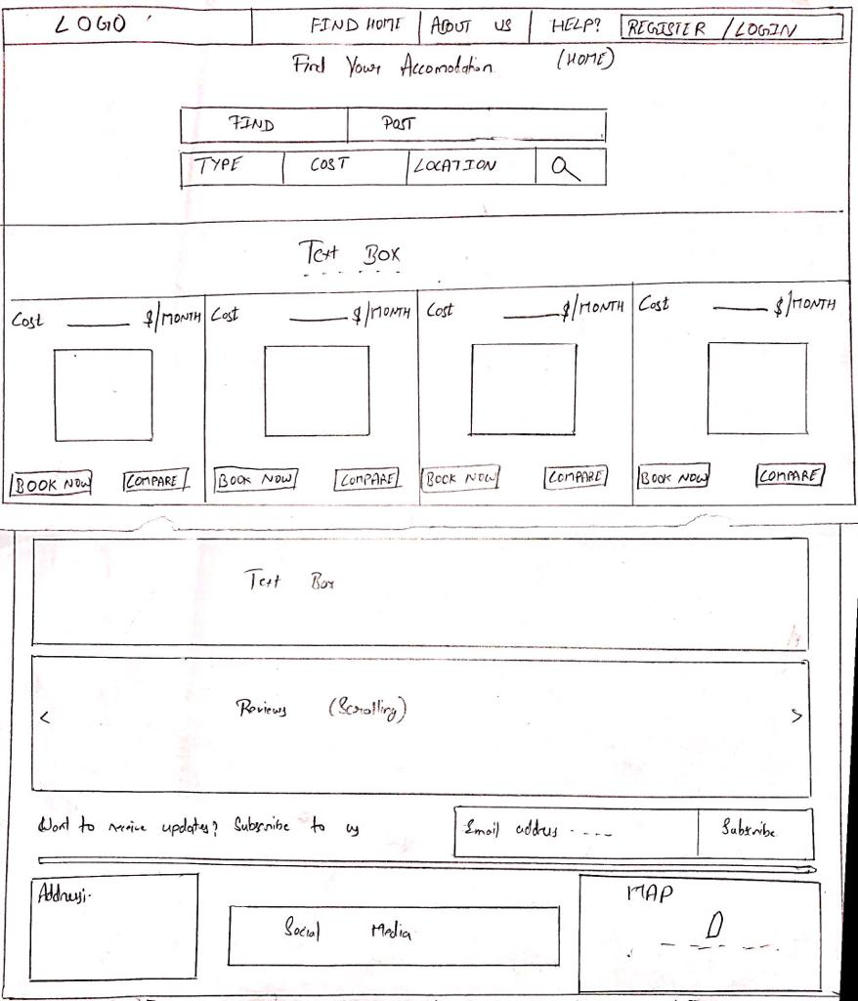

**Fig(1)**

* When the user clicks the Register/Login the following fig(2) page appears.

**REGISTER/LOGIN:-**

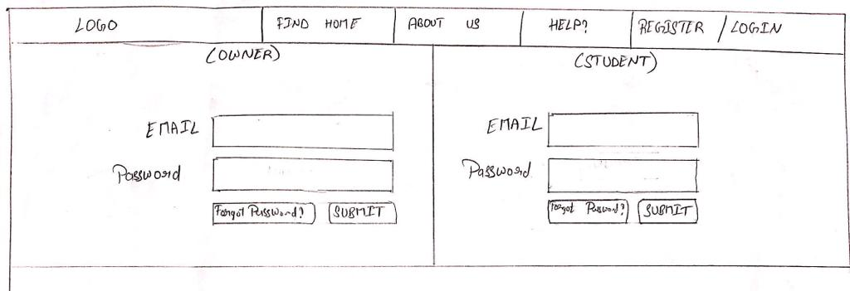

**Fig(2)**

* If the user already has an account he will login to it else he will create a new account giving all the information required.
* Below fig(3a) and fig(3b)are the account opening forms for the owner and the student respectively.

**Owner account opening;-** 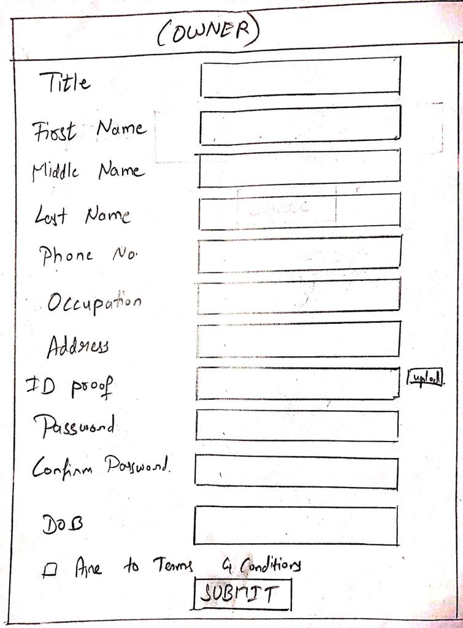

**Fig(3a)**

**Student account opening;-**

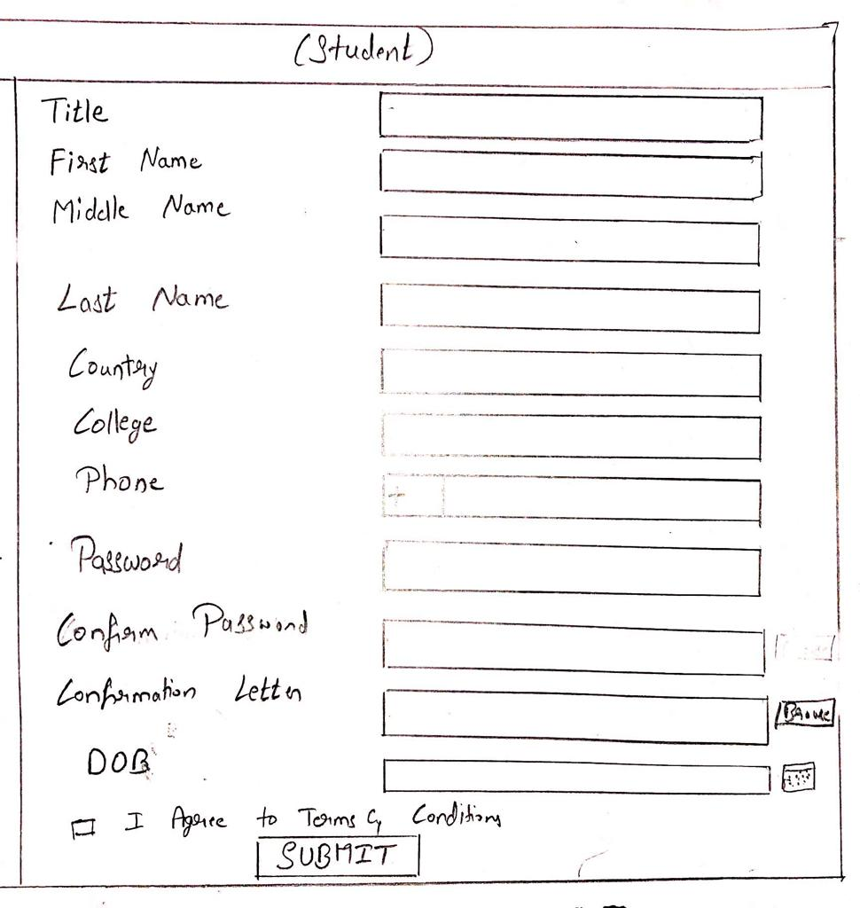

**Fig(3b)**

* Once the user creats his account he can view all the information of the selected house.
* In the below fig the student can view the basic information about the home.
* All the information and ratings of the home are provided here except the owner information and the exact location of home.
* The complete address will be provided when the minimum payment is done by the student to the owner.
* The create accommodation fig(4) is for owner to upload his home details.
* In the next window fig(5) the student can compare multiple houses in the same window and select the best among them.

**Create Accomadation:-**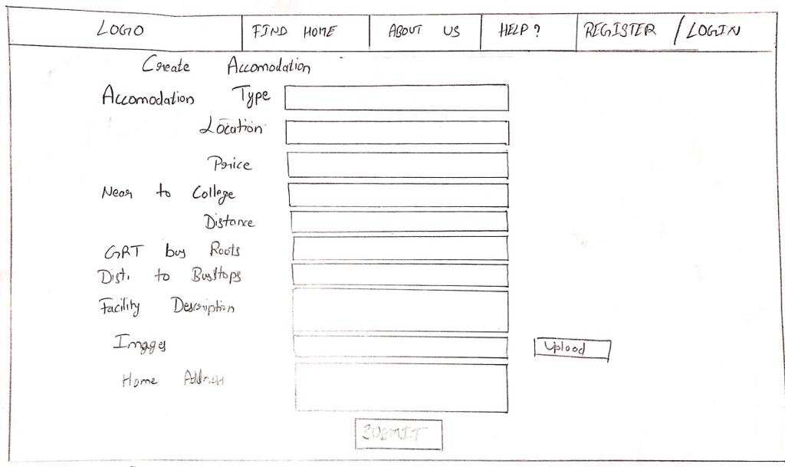

**Fig(4)**

* The below fig(5) is the comparison window.

**Compare Window;-**

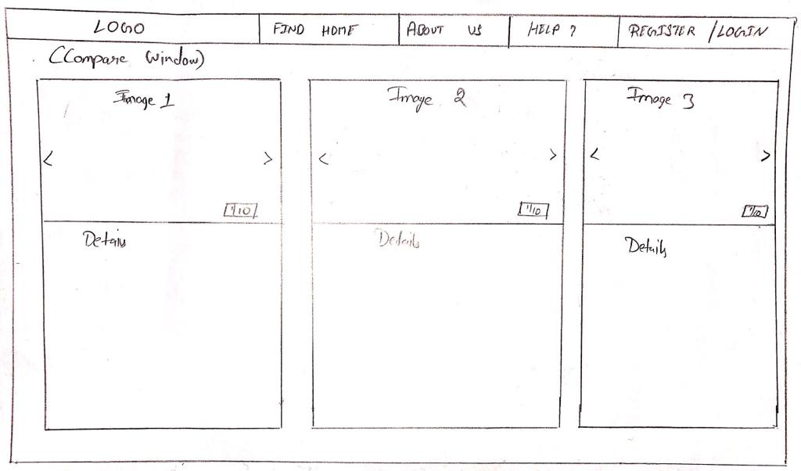 **Fig(5)**

* Once the student selects any particular house it redirects to the owner and the live chat among the owner and the student page fig(6a) is opened.
* Fig(6a) describers the owner point of view page.
* Fig(6b) describes the student point of view page.
* Fig(6c) describes the page for student if owner rejects the deal.
* In the Fig(5a) the owner will have option to Reject or Confirm the deal, If the deal is confirmed by owner it will be reflected into Fig(5b) where student will get **PAY NOW** button by pressing that button student will be redirected to the payment gateway fig(7) page.

**Owner Message box:-**

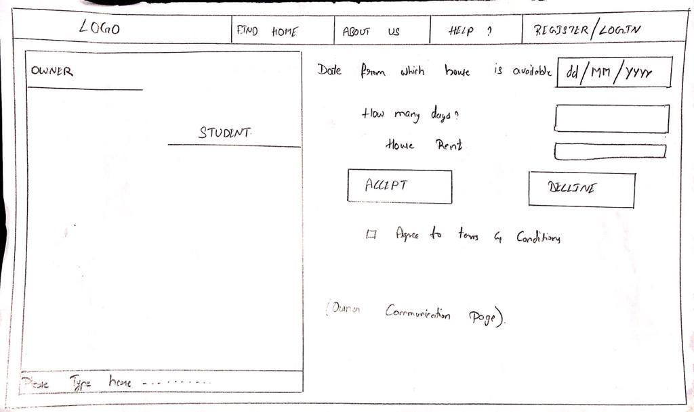

**Fig(6a)**

**Students Mesaage box:-**

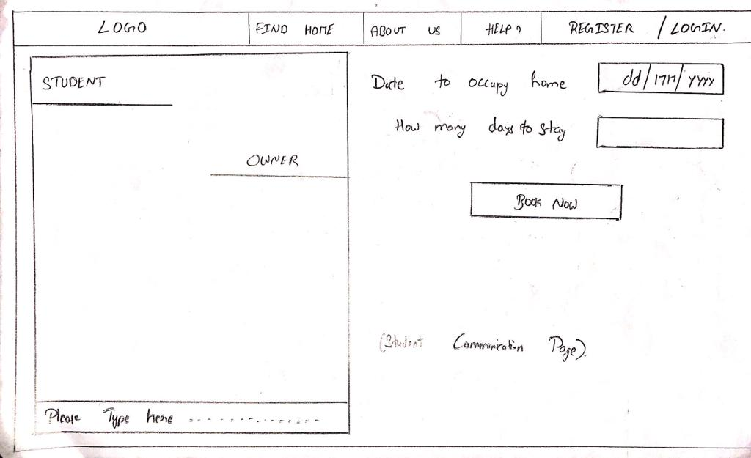

**Fig(6b)**

**Student message box when owner cancels deal:-**

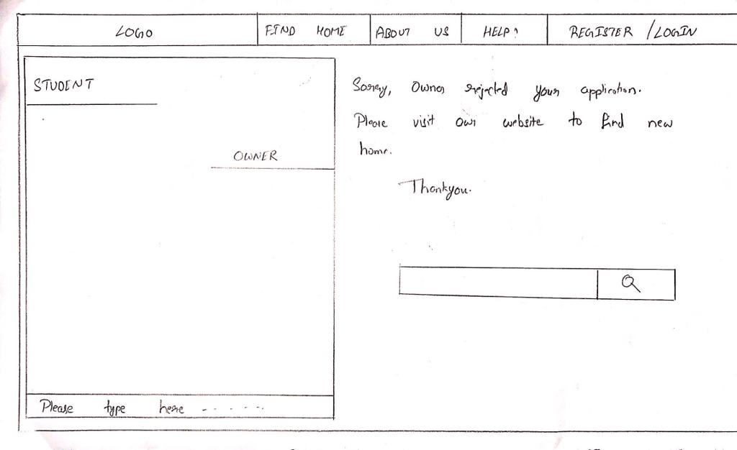

**Fig(6c)**

**Payment Gateway:-**

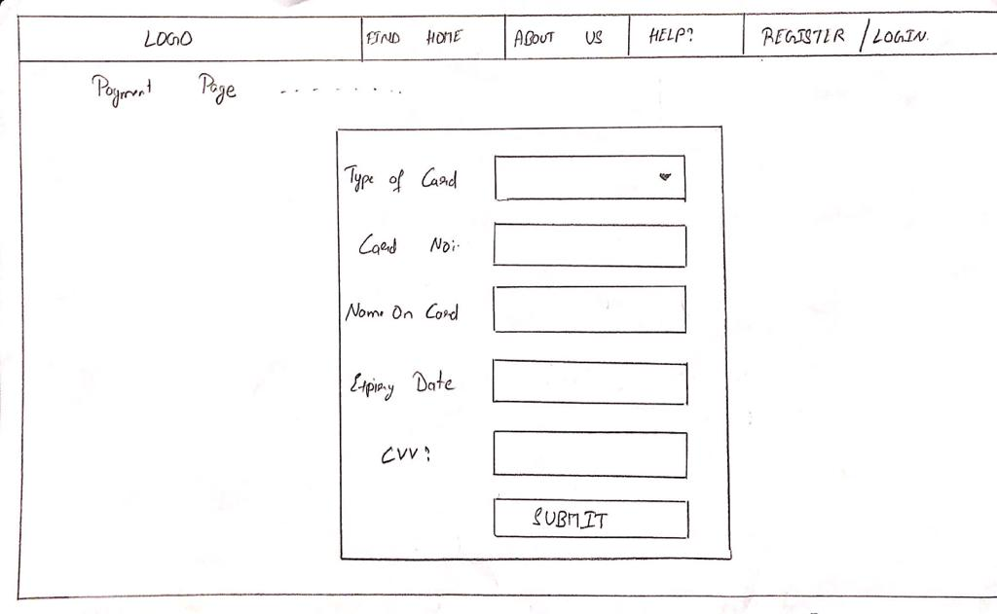

**Fig(7)**

* Once the payment is done in the next page a Confirmation letter fig(8) is sent to both the owner and the student with all the information about the deal.
* In the confirmation letter all the details including the full address, payment and the number of days the student staying at that home with the start date and the end date is all specified in that.
* With all this information a link to download the page in pdf format is also provided.

**Confirmation Page:-**

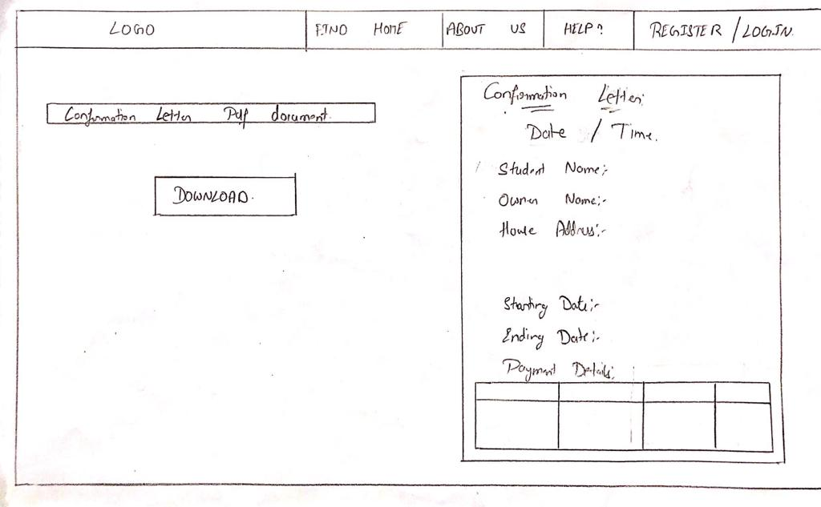

**Fig(8)**

* **T**he below is the Issue Solving page fig(9) where all the FAQ’s and the related quires will be solved to the users.
* Here the user can ask for the new query or he can relate his query with the available FAQ’s on the page.

**Issue Solving:-**

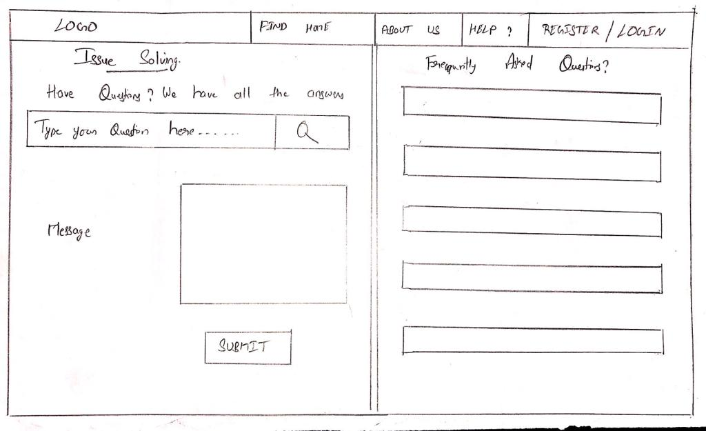

**Fig(9)**

* Once all the transaction is successful the users will be redirected to the Ratings page fig(10) where he can rate our website.

**Ratings Page:-** 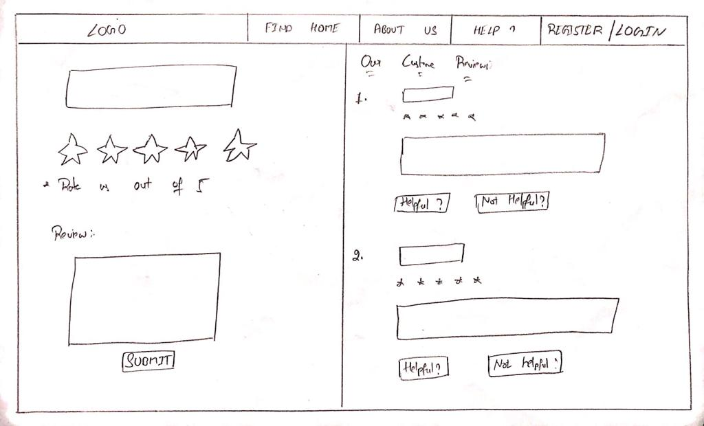

**Fig(10)**

**Admin Page:-**

* The below page fig(11) is the admin page where only admins will have access to this page.

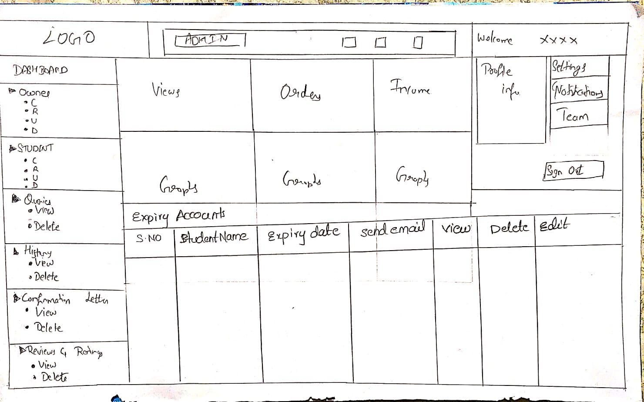

**Fig(11)**

**---THANK YOU---**